CSCE 4444 Deliverable 1

CAPP

Idle Walker Game

Andrew Buikema

Cameron Fullerton

Phillip Buckreis

Peter Hansen

**Project Description**

We are making an Android app named Idle Walker. It is an “idle game” that makes the users walk to win. The footsteps are the “clicks”, and each step gives you a certain number of points. After progressing through the game, upgrades may be purchased with points. These upgrades allow the player to earn more points through point multipliers or “auto-walkers”, where the game walks for the player for a short amount of time. Auto-walkers are expensive, but generate points while the user is not able to walk. Every time you upgrade an auto-walker, it becomes increasingly more expensive.

Throughout the game, there are paths that the player has to walk. During these paths, the player can encounter enemies that they can fight for more points and upgrades. At the end of each path is a mini-boss that, when defeated, grants the player a treasure box to upgrade their equipment. When a path is completed and the mini-boss defeated, a new path starts, but the amount of points required to complete the path increases. There will be a set amount of levels each with their own paths, but the game can be played indefinitely with enemies getting progressively more difficult and equipment becoming stronger.

The goal of the game is to complete steps, collect points, buy upgrades and defeat enemies. The game is considered complete when they defeat the final boss in the final level, however the game will continue endlessly.

Our game may or may not contain additional elements from the RPG game genre, such as an inventory system to keep track of items, a unique battle system with randomized enemies, and a story.

The game is supposed to encourage exercise through walking. To progress in the game, the player must walk. Auto-walkers can help progress the player in other ways, but ultimately needs to walk to complete a path. Rewards for walking are given frequently and our application will include data such as total step count, total estimated distance, total estimated calories. These reading will require data about the player, but they’re optional.

We will be working in Android Studio for our game and it will start as an application for phones. We are considering supporting wearables, such as smartwatches or fitness trackers, but our focus on this project is for Android phones. We will be using Java and XML to program our game.

**Meeting Minutes**

Group Meeting 1 was held on Monday 9/11 at 7pm - 9pm group members involved were Andrew, Cameron, and Phillip. Topics discussed involved Deliverable 1, risk management, and ideas for our game.

Talks over deliverable 1 involved using a google docs, which we opted to use for reports. We also talked over the name for our game. We decided to make the game as described above with the possibility of increasing the difficulty of the project if we have time.

Phillip worked on a Gantt Chart document and we started work on deliverable 1. We typed out a template using google docs and then made a separate document to complete the task.

We spent the majority of the meeting talking about risks to the project and managing them. How to handle situations and keep track of progress.

* Knowledge

Monitoring? Keeping up with coding and grammar

Re-evaluation? weekly updates on progress and struggles

Contingencies? work as a group to solve issues.

* Access to hardware / software

Monitoring? Work while on campus/bring laptops with

Re-evaluation? Find more accessible computers/software

Contingencies? Andrew brings both laptops and work every class day before class.

* Difficulty of project

Monitoring? Meet deadlines, make weekly progress

Re-evaluation? Check up to make sure deadlines can realistically be met.

Contingencies? Decrease scope.

* Scheduling conflicts

Monitoring? Make meetings days before, so people can schedule.

Re-evaluation? Pair with team members that can meet.

Contingencies? Use Skype or another client.

* Team members weaknesses/lack of involvement

Monitoring? Meetings.

Re-evaluation? Nobody can make the meetings or make time to work on the project

Contingencies? Frequent check-ups. Pairing up.

Group Meeting 2 was held on Tuesday 9/12 at 3:00 - 3:50PM group members involved were Andrew, Cameron, and Phillip. Topics discussed involved Deliverable 1, Project Proposal Presentation and clarification of the project details.

Work was continued on Deliverable 1 to add new details about the timeline and description of the game. Phillip was a bit confused in the direction the game was going, but Andrew and Cameron clarified some of the features.

Cameron started a Google Slide outline for the Project Proposal Presentation. He included what each slide will cover as well as the format and style of our presentation.

**Timeline**

9/13 - Deliverable 1

9/14 - Project proposal Presentation

9/23 - *Step Counter, Random Encounter, Sample UI, Stats Page*

9/30 - *Randomized Weapons*

10/7 - *Inventory System*

10/10 - Deliverable 2

10/14 - *Loot Box System*

10/28 - *Battle System, Music/Sound*

11/04 - *Enemy AI*

11/13 - Code inspection

11/18 - *Graphics*

11/27 - Code completion

11/27 - Final report

11/28 - Class demo and presentation

12/2 - *Finalize UI, Added Content*

12/5 - in class usability testing

**Gantt Chart**

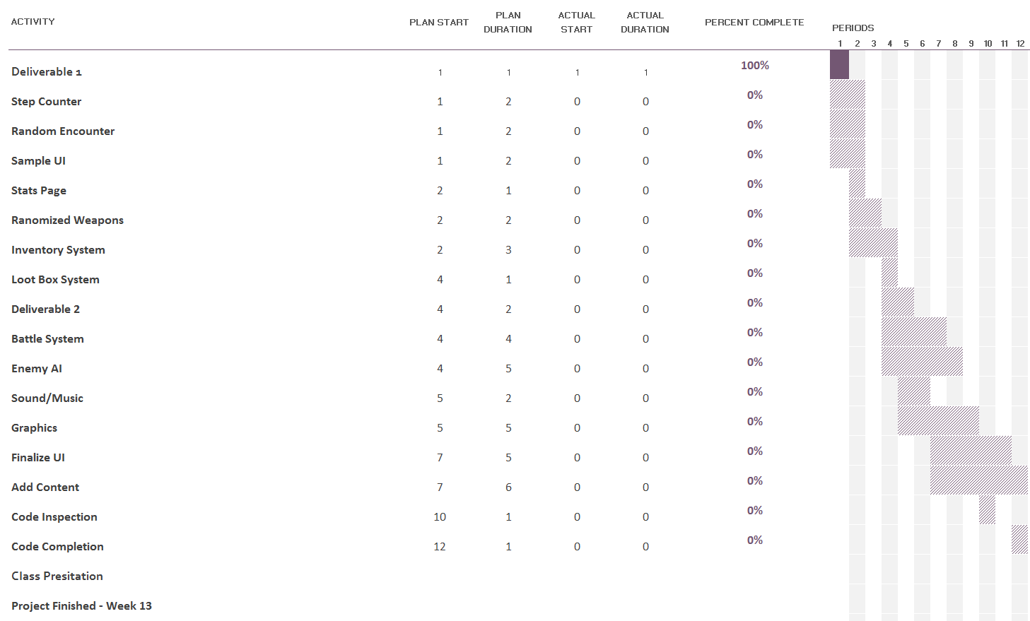

This Gantt chart is an estimation of our workload and duration. Since we’re still early in development of our application, dates and activities are subject to change. We are opting to use a Prototyping development cycle with frequent prototypes and testing to make sure our application is working as intended.

**Risk Management**

During the initial planning of this project, we came up with a list of possible risks and a system of monitoring, re-evaluation, and possible contingencies for each risk.

* *Knowledge*

Not everyone in the group has the same knowledge, whether it be software, programming languages, or even operating systems. One way to monitor that everybody is on track with knowledge is to simply keep up with coding and grammar of different languages. We will re-evaluate this risk based on weekly updates and notes of struggles among the group. Our contingency for this risk is to work as a group to solve issues.

* *Access to hardware/software*

We are college students. There is a chance that not everybody has access to a computer at home, or that not everybody in the group has access to the software being used. We can monitor this by doing most of our work while on-campus, or by bringing laptops to class. We will re-evaluate this risk by finding more accessible computers and/or software. Our contingency for this risk is that Andrew brings both of his laptops so everybody has a chance to work, and we will work before and after class.

* *Difficulty of the project*

It may turn out that the project is just too difficult for us to finish. This is a very possible risk. We plan on monitoring this risk by making and meeting our own deadlines, to ensure we make a certain amount of progress every week. We will re-evaluate this risk by Checking up with each other to make sure that the deadlines can realistically be met. Our contingency for this risk is to decrease the scope of the project. If we can meet a deadline, we’ll take a not-as-important feature out or postpone that feature.

* *Team member’s weakness/lack of involvement*

A team member might have a weakness that hinders the group’s progress, or a team member may not participate in all of the group meetings and work days. One way we can monitor this is through multiple means of communication and having frequent meetings. We can re-evaluate this risk by noting if nobody can make the meetings or if they cannot make time to work on the project. Our contingency for this risk is to have frequent check-ups or to pair up when working on the project.

* *Scheduling conflicts*

We are in school, and everybody’s class schedule is different. There are going to be scheduling conflicts here and there. We can monitor this by scheduling the meetings days or weeks beforehand, so that people can schedule around the meetings. We will re-evaluate this risk by making sure there can always be at least two people that can meet. Our contingency for this risk is we can use Skype or some other meeting client.

**Summary**

As of 9/12 the deliverable is complete. We had a couple class meetings and one out of class meeting to discuss how we were going to go about doing the deliverable and complete on time. Team members involved in the report were Andrew, Lead developer, Phillip, Game designer, and Cameron, Team leader. Who had all discussed at the team meeting about the deliverable and how to tackle the different sections. Phillip took meeting minutes and worked on a Gantt chart, both of which were then used to complete the related sections Meeting Minutes and Timeline. Cameron also typed up the summary section. Andrew typed out the risk management section elaborating on meeting minutes taken about risks and how to manage them.

The repository checkout and update policies have not been discussed as of yet due to the fact we have been using google docs to type things out thus far meaning we can adjust and edit documents simultaneously. If it becomes an issue with future deliverables and documentation we will discuss and create appropriate policies.

**Member Contribution Table**

|  |  |  |  |
| --- | --- | --- | --- |
| Name | Contribution Description | Contribution (%) | Notes |
| Phillip Buckreis | Gantt chart, proofreading, and project description elaboration | 29 |  |
| Andrew Buikema | Project proposal basic ideas, Risk management | 29 |  |
| Cameron Fullerton | Timeline layout,meeting minutes, summary and slide show. | 29 | Failed to communicate effectively the work was being edited on google drive to all team members. |
| Peter Hansen | Finalized slide show and proofread deliverable. | 13 | Didn’t realise had access to google drive. |